Watch Main Page | https://swissiceco.com/pages/watches | Pre Owned Watches Brands  Pre Owned luxury watches  Swiss Luxury timepieces  Diamond watch  luxury watches  luxury watch brands  luxury watches for men  mens luxury watch  mens luxury watches
Meta Title:
Shop Certified Pre-Owned Watch Brands
Meta Description:
Explore an extensive collection of Pre Owned Watches of Luxurious Brands at Swiss Ice Co. ✓ 30 days money back guarantee ✓ Buyer Protection

Pre Owned Watches Brands
Welcome to Swiss Ice Co, the leading source of pristine pre owned watches brands. Our specialists are passionate and dedicated to carefully selecting each watch from the huge variety of the world’s premier pre-owned watches. Whether you prefer traditional watches or futuristic watches of desire we offer you the greatest choice of watches available.

Shop Now

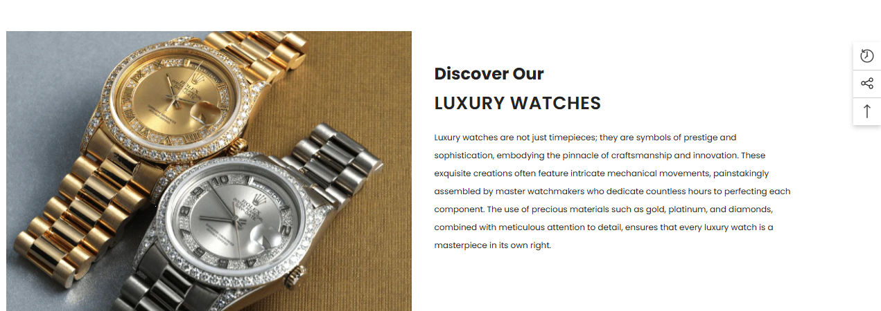

Explore Our Collection Of Certified Pre Owned luxury watches:

Blending tradition and quality, our pre-owned timepieces showcase timeless charm at our stores in San Francisco and Los Angeles. The timepieces we offer in our collection are handmade by the best Swiss Luxury timepieces brands and companies specializing in watchmaking. We have a collection of some of the most iconic timepieces in the world including Rolex and Omega; each piece speaks volumes to their grandmasters.

Brands
Swiss Ice Co boasts of having a collection of Pre Owned Watches of luxurious brands. Choose from our collection of exquisite timepiece collections from leading brands around the world and feel the class. Here's a sneak peek at some of the brands that make our collection unique:
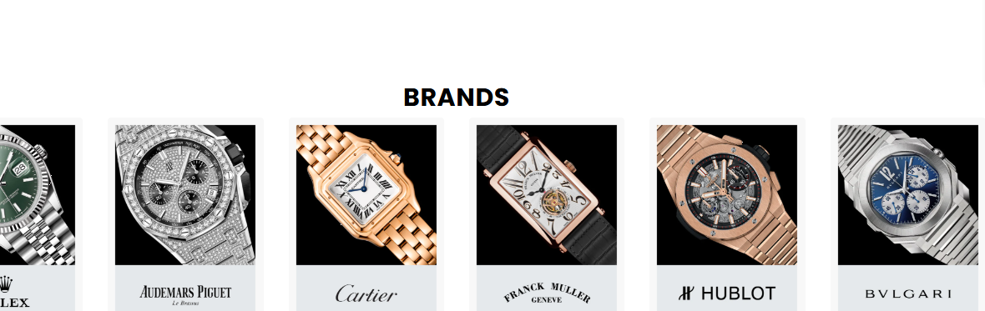

Latest Rolex Collection
Swiss Ice Co has the finest collection of men's luxury watches of the Rolex brand, ready to be owned. Discover our new range of time accessories and admire marvelous models of Rolex men's luxury watches that will fit any style. We are proud to offer an exquisite range of Rolex watches, including:

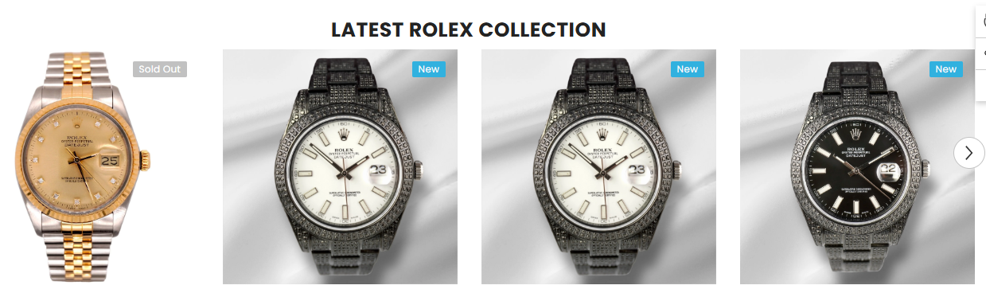

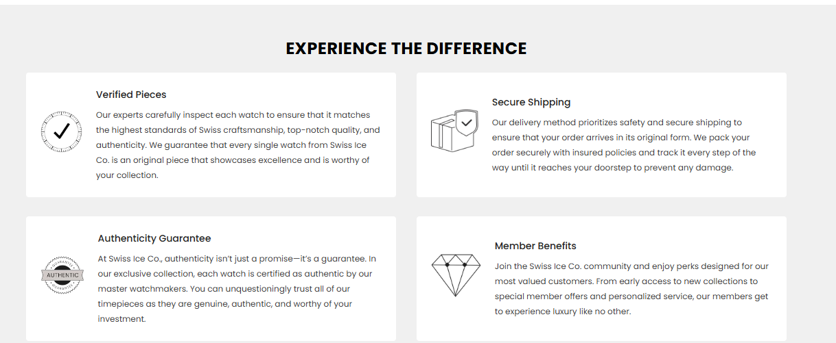

Savor Yourself With the Enjoyment of Pre-Owned Watches:

Impeccable Authenticity | Secure Shipping Experience
Our staff of horological specialists personally examines each used diamond watch with the utmost care to guarantee that both you and the seller have a genuine masterpiece that is worthy of being kept in the treasure trove of your favorite timepieces without any headache. | Swiss Ice Co appreciates the value of your investment, thus ensuring the safe arrival of your luxury watches. With secure packaging and insured delivery, we ensure that your watch arrives at your doorstep in the same condition as when it left our store to give you full enjoyment.
A Guarantee of Quality: | Exclusive Member Benefits
Here at Swiss Ice Co, we give our promise to supply only genuine and excellent quality luxury watch brands. The master watchmakers at our store have personally worn and rigorously tested each watch in our extensive line of watches to ensure the authenticity of Swiss quality. | Swiss Ice Co would like to invite you to become part of our family and get benefits from a list of privileges. Our exclusive services include early access to new luxury watches for men collections and special offers that will let you touch the unique taste of the luxury space.

FAQ’s

What is a pre-owned watch?

A used watch refers to a watch that has been in the possession of a previous owner.

Are second-hand watches fit to use?

Yes, second-hand watches are fit to use in fact they are equally as good as new ones. There is one thing that you need to make sure of is that you buy these second-hand watches from a trusted source such as Swiss ice

What should I do to be sure that the pre-owned watch is original?

If you want to avoid buying counterfeiting watches then Swiss Ice Co is your one-stop solution. At Swiss Ice Co, customers can buy original and genuine used watches. With so many fake pieces around the market, our professional staff carefully analyze each watch before we start adding it to our list.

What is your return policy?
At Swiss Ice Co, we know that time may be required to find your ideal watch. However, if you are unsatisfied with the product we are willing to provide you with a free return within 30 days upon receipt of the product. You only have to reach out to our Customer Service Department and we shall gladly be of help.

What is the difference between a pre-owned watch and a vintage watch?

A second-hand watch means a watch that has been in use by somebody else but is functional and still in a serviceable condition. Normally it is sold by the first owner or a second-hand seller and often comes in slightly used condition. However, a vintage watch is a type of watch that is at least 20-25 years old and has some history or inherited value attached to it.

